Excel Assignment - 16

1. **What is a Macro? How is it useful in excel or in your daily work?**

**Answer**: In Excel, a macro is a set of instructions that can be used to automate a repetitive task.

Macros are written in Visual Basics for Applications (VBA), a programming language for office applications.

* Macros make it easy to do automatic tasks in Microsoft Excel.
* To create macros yourself, you'll need to enable macros in the Developer menu of Ex.
* Saving a macro-enabled spreadsheet is a little different than saving a spreadsheet without macros.

Macros can save time and reduce errors by automating tasks that you perform frequently. For example, macros can clear the contents of certain cells or copy and paste data from one sheet to another. Macros can also be used to format a report or to print a specific range of cells.

To use a macro in excel, you first need to create it and save it in the workbook. Thereafter, you can run macro by clicking a button on toolbar.

===================================================================================

1. **What is VBA? Write its full form and briefly explain why VBA is used in excel?**

**Answer**: VBA stands for Visual Basic for Applications. It is a programming language that is used to create macros in office applications such as Excel, Word and Power Point.

VBA is an event-driven programming language, which means that you can use it to create programs that responds to various events such as a user clicking a button or a key press. It is integrated into the office applications.

VBA is used in Excel to automate tasks such as formatting and manipulating data, creating charts and graphs and performing calculations. It is a powerful tool that can help you save time and reduce errors by automating repetitive tasks.

VBA also very useful for creating custom functions and adding new features to excel that are not available in the built-in functions.

1. **How do you record a macro? Write detailed steps to create a macro to automatically make the following table in bold and to create borders for it in excel.**

**Answer**: Created this macros and recorded a video: <https://youtu.be/N8HTJoHq_3o>

To record a macro in Excel, follow these steps:

|  |  |
| --- | --- |
|  | 1. Open the workbook in which you want to create the macro. 2. On the Ribbon, click the "Developer" tab. If the Developer tab is not visible, you may need to enable it. To do this, click "File" > "Options" > "Customize Ribbon", and then check the box next to "Developer" in the list of main tabs. 3. In the "Code" group, click the "Record Macro" button. 4. In the "Record Macro" dialog box, enter a name for the macro in the "Macro name" field. 5. Optional: If you want to run the macro by pressing a shortcut key, you can assign a shortcut key by typing it in the "Shortcut key" field. 6. Optional: If you want to add the macro to a custom group on the Ribbon, select a custom group from the "Store macro in" dropdown list. 7. Click "OK" to start recording the macro. 8. Perform the actions that you want to include in the macro. For example, to make the table bold and add borders to it, select the cells in the table, then click the "Bold" button in the "Font" group on the Ribbon and click the "Borders" button in the "Font" group. 9. When you are finished recording the macro, click the "Stop Recording" button in the "Code" group on the Ribbon. |

The macro will now be saved in the workbook, and you can run it by clicking the "Macros" button in the "Code" group on the Ribbon and selecting the macro from the list, or by using the shortcut key that you assigned, if applicable.

1. What do you mean when we say VBA Editor?

**Answer**: The Visual Basic for Application editor is a component of the Microsoft Office suite that allows users to create and edit VBA code. The VBA editor is also referred to as the VBA Integrated Development Environment (IDE).

It is a separate window that opens when you create or edit a VBA macro in an office application. The VBA editor provides a number of tools and features that you can use to write and debug your VBA code.

1. **Briefly describe the interface of a VBA editor? What is a properties window? And what is watch window? How do you display these windows?**

**Answer**: Go to “Developer”> Visual Basics

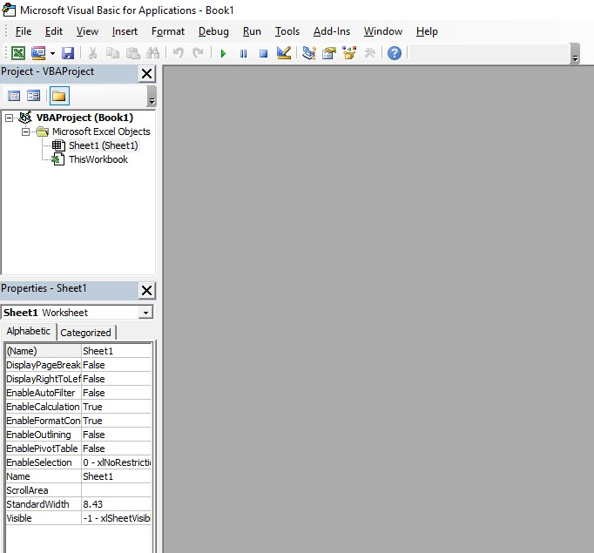

The VBA editor interface consists of a number of windows and panels that you can use to create, edit, and debug your VBA code.

The Properties window is a panel that displays the properties of the currently selected object in the VBA project. You can use the Properties window to view and modify the properties of an object, such as the name, value, or caption of a control.

The Watch window is a panel that allows you to monitor the value of a variable or expression as your code is running. You can use the Watch window to see the value of a variable or expression change as your code executes, which can be useful for debugging purposes.

To display the Properties and Watch windows, you can go to the View menu in the VBA editor and select the Properties Window or Watch Window option. You can also use the keyboard shortcuts F4 and F5, respectively, to toggle these windows on and off.

6. What is an immediate Window and what is it used for?

**Answer**: The Immediate window is a panel in the VBA editor that allows you to execute VBA code on the fly and view the results of your code. You can use the Immediate window to test code snippets, debug your code, or run VBA procedures without having to write a full program.

To use the Immediate window, you can type a line of code into the window and press Enter to execute it. The Immediate window will then display the result of the code, if any. You can also use the Immediate window to print values or debug information by using the Debug.Print() function.

The Immediate window can be very useful when you are working on a large VBA project and need to test or debug a specific piece of code. You can use the Immediate window to quickly test and troubleshoot your code without having to run the entire program. To display the Immediate window, you can go to the View menu in the VBA editor and select the Immediate Window option, or use the keyboard shortcut Ctrl+G.